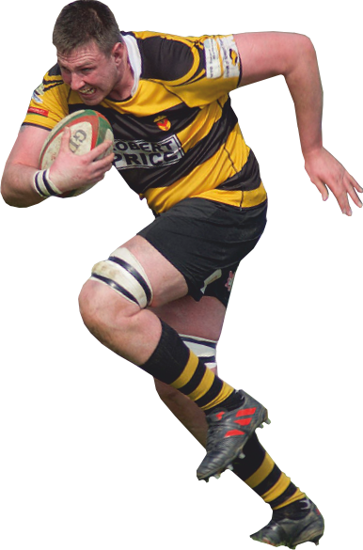

**BLACK AND AMBERS**

**Advertising and Sponsorship opportunities at Newport RFC provide you with a fantastic platform to increase your company’s profile, exposing your brand to a captive audience.**



**MATCH PROGRAMME ADVERTISING**

* Full gloss colour for the whole season
* Full Page - **£500**
* Half Page - **£250**
* Quarter Page - **£125**

**Kevin Jarvis**

**07734 740218**.

kevin.jarvis@ntlworld.com

**Steve Maguire**

**07449 325383**.

steve.maguire@ntlworld.com

**WEBSITE ADVERTISING**

* Your company logo & website link from the homepage of the Newport RFC website.
* Right to buy 10 tickets for every home Wales international match

**£500 – Plus VAT**

**KIT SPONSORSHIP PACKAGE**

* Box for up to 10 people for every league home game
* Pitch side advertising banner
* Complimentary match programmes
* Meet the player opportunities
* Company logo displayed prominently on the playing kit
* Right to buy 10 tickets for every home Wales international match
* Refreshments & catering in addition

**Price on application**

Sponsorship packages include access to international tickets

**For further information regarding sponsorship opportunities with Newport RFC please contact**

**BALL SPONSORSHIP**

* 6 Bisley Stand match tickets
* Company name in the match programme
* Company name announced at match
* Signed ball

**£200**

**MATCH SPONSORSHIP**

* 10 Bisley Stand match tickets
* Use of Corporate Box
* £100 of drinks vouchers
* Cold finger buffet
* Company name in the match programme
* Company name announced at match
* Complimentary match programmes

**£600**

**MATCH BY MATCH BOX HIRE**

* Use of a Bisley Stand Box for up to 10 guests
* Cold finger buffet
* Other packages with drinks and hot food available. Price on application.

**£500**